INFORMATION PACK

Applications under the Right to Information Act 2009

This information pack gives an overview of what you can expect to occur as the department processes your application for information under the Right to Information Act 2009 (RTI Act).
See page 2 for information about how the department manages your personal information throughout the application process. Page 10 contains important information about secure email access.
Charges Estimate Notice
Notice of decision
Third party consultation
Application acknowledgement
Application received by the department
Disclosure log:
Publish documents and name of applicant and entity
Review
When an application is received by the department, we will:
Decide whether the application should be made and dealt with under the RTI Act or the IP Act (see page 2)
Decide whether the application is compliant with requirements (see page 3)
Decide whether we hold documents relevant to the request, or if the application should be dealt with by another agency (see page 3).
Once your application is confirmed as a compliant application under the RTI Act, you will receive an acknowledgement letter from us. We will then undertake searches in relevant locations within the department. We may need further information from you to help locate where relevant documents might be held.
We will also publish the terms of your application and the date upon which it became compliant, on the department’s disclosure log.
See pages 10-11 about disclosure logs
See pages 3-4 for information about additional supporting information;
See pages 3-5 for fees and charges;
See pages 5-6 for the timeframes.
Once we have located the documents responsive to your request, we will issue you with a Charges Estimate Notice. See pages 4-5 for more information about Charges Estimate Notices; and page 7 for information about how Charges Estimate Notices affect application timeframes.
The Act may require us to consult with third parties about the release of information to you that concerns them. See pages 7-8 for more information about third party consultation processes.
Each application is decided by a decision maker who will be in contact with you during the process. Once your application has been considered, you will be issued with a notice of the decision made, along with a statement of reasons for the decision. See pages 8-10 for information about the types of decisions that can be made under the Act.
In some circumstances, documents released under an access application may be published on the department’s disclosure log website. See pages 10-11 for more information about disclosure logs.
In most cases, you will have rights of review of the decision made on your application. You can apply for internal review by the department or external review by the Office of the Information Commissioner. See page 11 for more information about review.
Publish terms of application in disclosure log

Privacy Notice

What is personal information?
Section 12 of the Information Privacy Act 2009 (IP Act) provides the definition of personal information, which is as follows:
Personal information is information or an opinion forming part of a database, whether true or not, and whether recorded in a material form or not, about an individual whose identity is apparent, or can reasonably be ascertained, from the information or opinion.
The Department of Families, Seniors, Disability Services and Child Safety collects personal information for the purposes of processing applications under the RTI Act or the IP Act. It will be used for purposes related to processing your application including searching records and conferring with relevant parties as well as for general administrative purposes including reporting, performance improvement and assessing statutory compliance. Your personal information will be managed in accordance with the IP Act.

Under the RTI and IP Acts, your personal information may be disclosed to other Queensland Government agencies for the purposes of transferring all or part of your application if necessary. It may also be disclosed to other parties for the purpose of ascertaining their views on disclosure of the documents to you, as provided for under the RTI Act and IP Acts. Your personal information may also be provided to monitoring and appeal bodies, including the Information Commissioner, for the purpose of participating in any external review or appeal processes relating to your application under the RTI or IP Acts or for monitoring of the department’s compliance with the legislation.

Right to Information Act 2009 vs Information Privacy 2009
What’s the difference?
Both the RTI Act and IP Act give a person a right to access information held by Queensland Government agencies. Your application is likely to be handled under the RTI Act if:
- you have applied for access to the personal information of individuals other than you; OR
- you have applied for access to your own personal information and the personal information of individuals other than you; OR
- you have applied for corporate documents which do not contain personal information.
There is an application fee if you apply under the RTI Act (visit http://www.rti.qld.gov.au/fees-and-charges for the current application fee amount, and see pages 4-5 for more information about fees and charges). Your application is likely to be handled under the IP Act if you have applied for access to documents containing your own personal information. There is no application fee to be paid if you apply under the IP Act, but there may be other charges involved.

There is one application form to apply under either of the two Acts – so if the application is made under the incorrect Act, you will be advised and you will be given the opportunity to change your application type or to change the type of information you are seeking.

Transfer of an application
If all, or part, of the documents relevant to your request are likely to be held by another agency or Minister, we will liaise with that agency or Minister to:
- confirm that it holds, or is likely to hold, the documents; and
- obtain consent to a full or part transfer.

If the other agency or Minister consents to the transfer, we will advise you and transfer your application, or part of your application to the other agency. If the other agency or Minister does not consent to the transfer, we will advise you to lodge an application directly with that agency or Minister. You will then be able to:
- withdraw your application to the department, in whole or in part; or
- continue with your application to the department. You will then be issued with a decision that the department does not hold documents relevant to your request or part of your request.

Meeting the statutory requirements for a compliant application
In order for your application to be compliant under the Act, it must:
- be made in the prescribed form, either online or in hard copy;
- be accompanied by the application fee;
- give sufficient information concerning the document/s you are seeking to enable the documents to be identified;
- state an address to which notices under the RTI Act can be sent; and
- state whether access to the document is sought for the benefit of, or use of the document by the applicant or another entity and if it is for the benefit of or use by another entity, the name of the entity.
If your application seeks access to your own personal information, you must provide proof of your identity. If another person is acting on your behalf to make this application, they must provide:
- proof of their identity; and
- evidence that they have your authority to act on your behalf.

Proof of identity
You may present evidence of identity in person to the Information Access and Amendment Unit in Brisbane, or provide a certified copy of your identity documentation. Examples of evidence which will be accepted include: current passport, driver’s licence or birth certificate. The Act requires all copies of documents proving identity to be certified by a lawyer, notary public, a commissioner for declarations or a justice of the peace. Please ensure that you forward the document with the certifying officer’s original signature. A photocopy of the certifying officer’s signature cannot be accepted.

We may be able to arrange for you to visit a local service centre of the department to present your identification if this is most convenient. Please phone our office on 07 3097 5605 or freecall 1800 809 078 to enquire about presenting your identification locally.

Personal information of another person
If you have requested access to personal information of another person, you may wish to provide the decision maker with information that supports your case for giving that information to you. Where the personal information concerns a family member or there is some other special relationship, it may be helpful to provide evidence of the relationship, for example, a birth certificate where the parents or siblings are named or guardianship or other court order.

Fees and charges

Application fee

An application fee must be paid when you apply for information under the RTI Act. The application fee cannot be waived. An application is not compliant and no action can be taken on it until the fee is paid.

Processing charges
You will be required to pay a processing charge if the department spends more than five hours processing your application to the extent it does not contain your personal information. The processing charge is payable in 15 minute increments in relation to the whole time spent processing the application (including the first five hours).

You can be charged for:
- searching for or retrieving the document;
- making a decision on the application; and
- doing things related to making a decision on the application.

Please note, there are no processing charges for documents that contain the applicant’s personal information. Current amounts of processing charges can be found at http://www.rti.qld.gov.au/fees-and-charges

You may be eligible for a waiver of processing and access charges – see pages 5-6 for more information.

Access charges
You may be required to pay an access charge for any documents released to you (in full or in part). Please note that there are no access charges where access is provided by way of CD or email.

Information about access charges, including the current prescribed amount and how they are charged, can be found at http://www.rti.qld.gov.au/fees-and-charges

Charges estimate notice
Before a decision is made you will be sent a charges estimate notice (CEN) outlining the types of documents located and the estimated costs involved (if any). You will then have 20 business days to:
- confirm the access application (agreeing to pay the charges); or
- narrow your application to reduce the charges; or
- withdraw your application.

If you do not respond within the time, your application will be taken as withdrawn at the end of the 20 business days (or any longer agreed period).

Once you have confirmed a charges estimate notice, the estimated amount set out in that notice is the maximum amount you will be required to pay. If the department spends less time processing your application than estimated, the department will charge you for the actual time spent. If the department spends more time processing your application than estimated, the department will only charge you the amount set out in the final charges estimate notice.

Final charges notified in decision

A decision will be sent to you and will include the final processing and access charges payable. Access will not be provided until all charges are paid.
Please note, you must pay the processing charge even if access to documents is refused or you do not access the documents within the relevant period.

Time limit for access
Your right to access the documents ceases if you don’t access them within the relevant period (40 business days of being notified of the department’s decision). If you need a longer period to access your documents, please contact us to arrange an extension of this time.

Waiver of charges
Application fee
The application fee cannot be waived.

Access and processing charges
Under the RTI Act, process and access charges may be waived in three circumstances:
- where it is uneconomical for the department to impose the charge;
- where the applicant applies for a waiver and is the holder of a relevant concession card; or
- where the applicant is a non-profit organisation that has been granted financial hardship status from the Information Commissioner.

Uneconomical waiver
Under the RTI Act, the department has the discretion to waive processing or access charges where it is uneconomical for the agency to impose the charge (that is, where the likely associated costs to the department in processing the charge are more than the likely amount of the charge). You will be notified if the department decides to waive your charges on this basis

How to apply for a waiver (individuals)
Under the RTI Act, you may apply for a waiver of charges. You may make this request at any stage of the application. The department must decide to waive those charges if you make a written request to have the processing and/or access charges waived and you show that you are a holder of one of the following current concession cards:
- a health care card or pensioner concession card under the Social Security Act 1991 (Cth); or
- a pensioner concession card issued by the department of the Commonwealth in which the Veterans’ Entitlements Act 1986 (Cth) is administered.

The guide below shows which concession cards are accepted. If you provide a copy please note that a copy of both sides is required. If you make a written request to have any applicable charges waived, the department is required to give you a written notice of its decision before the end of the application processing period. A decision by the department not to waive the charges is a reviewable decision. You may apply to have the decision reviewed by the department (internal review) or by the Information Commissioner (external review). See page 11 for more information on review.
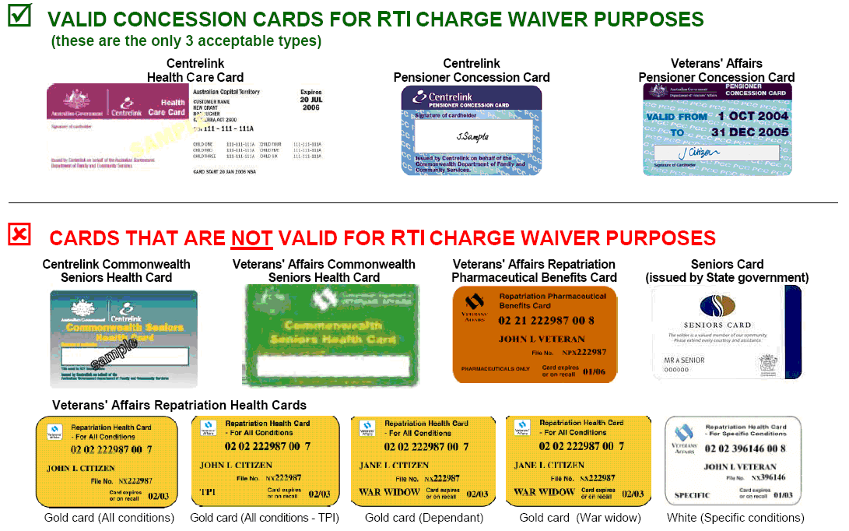

How to apply for a waiver (non-government organisations)
In accordance with section 66(2)(b) of the RTI Act, the department must waive any processing charge or access charge for the application if the applicant is a non-profit organisation that has received financial hardship status from the Information Commissioner.

Accordingly, if you have received financial hardship status, please provide the department with a copy of the prescribed written notice and any applicable processing or access charges will be waived.

Timeframes for notifying an RTI decision
Processing period
The department has 25 business days from the day an application becomes compliant to make a decision on the request (the processing period). However, throughout the application process, the processing period may be extended if one or more of these circumstances arise:

Transfer period
If an application is transferred to another agency or Minister the processing period is extended by the same length as the period starting on the day the application is received by the first agency or Minister and ending on the day the application is transferred to another agency or Minister; or 10 business days – whichever is the lesser.

Extension
If the department asks the applicant for a further period of time to consider the application, the processing period is extended by:
- the further period of time requested by the department if the applicant agrees to the request or does not respond to the request; or
- the period of time between the date of the department’s request and the date:
- the applicant notifies the department of their refusal of that request; or
- the date the department receives notice that the applicant has applied for a review under the RTI Act;
whichever comes first.

Charges estimate notice
If you are given a charges estimate notice the processing period stops and resumes on the date of your final response to the notice.

Third party consultation
If the agency is required under the RTI Act to consult with a third party, the processing period is extended by 10 business days.

Notice of intention to refuse to deal (diversion of resources)
If a notice of an intention to refuse to deal with the application on the grounds of diversion of resources, there is an additional 10 business day consultation period.

Third party consultation
Under the RTI Act, if the department is considering releasing information which, if disclosed, may reasonably be expected to be of concern to a government, agency or person (third party), the department must consult with the third party to obtain their views about whether:
- the relevant documents are documents to which the RTI Act does not apply; or
- the information contained in those documents is exempt information or contrary to public interest information.

The department must consider any relevant considerations raised by the third party in making its decision.

Deferred access
If the department decides to give the applicant access to documents and the decision is contrary to the views of a consulted third party, the department must:
- advise the third party of that decision. The third party will have 20 business days after the date on the decision letter to request a review of the decision; and
- defer access to the applicant until the period of 20 business days has passed or the third party’s avenues of review have been exhausted.

Disclosure of the applicant’s name
Please note that where the department is required to consult with a third party, the applicant’s name will ordinarily be given to that third party unless there is a significant reason for withholding the name of the applicant. If you do not want your name to be released to third parties, please advise the department as soon as possible. Please note that in some circumstances, who the applicant is may be information that a third party needs in order to form a view about the documents. In those circumstances, if you continue to object to the release of your name to the third party, the department will contact you to discuss the options available to you.

Decisions
The RTI Act provides for a range of decisions which may be reached including:
- a decision that the application is outside the scope of the RTI Act;
- a decision that the application is not compliant with the statutory requirements;
- a decision refusing to deal with the application;
- a decision that disclosure would not be in a child’s best interests;
- a decision that disclosure of relevant healthcare information might be prejudicial to the physical or mental health or wellbeing of an applicant;
- a decision that the documents requested do not exist or are unlocatable;
- a decision refusing access to the documents requested on the basis that other access is available;
- a decision neither confirming nor denying the existence of the type of documents requested;
- a decision that the access application is not limited to personal information;
- a considered decision; or
- a deemed decision.

Some of the more notable types of decisions are summarised below.

Noncompliant application
This is where an application is noncompliant because all the statutory requirements have not been met (see page 3). The department will:
- advise that your application is not compliant;
- advise which requirements you need to meet to make the application compliant; and
- provide a reasonable period of time (usually 10 business days) to make the application compliant.

If the necessary steps are not taken within the time given, a decision that the application is noncompliant will be issued. This means that the department will no longer be able to process the application. In those circumstances, a new application must be made.

Considered decision
The most common decision under the RTI Act is a considered decision about whether access is to be given to the requested documents and, if so, whether any charge must be paid before access is given.

The department may refuse access to a document to the extent it comprises:
- exempt information; or
- information the disclosure of which would, on balance, be contrary to the public interest.

Exempt information is set out in Schedule 3 of the Right to Information Act 2009 (RTI Act).
The factors that Parliament considers are relevant to deciding whether or not disclosure would be in the public interest are set out in Schedule 4 of the RTI Act.

Refuse to deal
The department may make a decision refusing to deal with the application if:
- on the face of the application, it appears that all relevant documents are comprised of exempt information (exempt information);
- the department considers that the work involved in dealing with the application would substantially and unreasonably divert the resources of the department from their use by the department in the performance of its functions (substantial and unreasonable diversion of resources); or
- the applicant has made a previous application for the same documents under either the RTI Act or IP Act and that application was not withdrawn (previous application for same documents).

We will ordinarily consult with the applicant before making a decision to refuse to deal.

Nonexistent or unlocatable
The department may make a decision refusing access to all or some of the documents where:
- the department is satisfied the documents do not exist; or
- the department is satisfied the documents have been or should be in the department’s possession and all reasonable steps have been taken to find the documents but they cannot be found.
Neither confirm nor deny
Under the RTI Act, an agency is not required to give information about the existence or non-existence of a document containing prescribed information.
Prescribed information means:
- exempt information mentioned in the RTI Act, schedule 3, section 1, 2, 3, 4, 5, 9 or 10; or
- personal information the disclosure of which would, on balance, be contrary to the public interest under the RTI Act, section 47(3)(b).

Prescribed information includes personal information the release of which would be contrary to the public interest, Cabinet information, information briefing incoming Ministers and law enforcement or public safety information.

Deemed decisions
If the department does not issue the notice of decision by the end of the processing period a decision refusing access is deemed to have been made. If a decision is deemed to have been made, a notice will be issued and there is a right of external review. There are also some cases where your application can be deemed withdrawn when you do not respond to, for example, a charges estimate notice. It is important to respond in the timeframe provided to avoid this. If you need more time to respond, always contact your decision maker to arrange an extension.

Access to your documents
When the decision maker decides to grant access to some or all of the documents you have sought access to, you have a choice as to how you access these documents. The department offers access via paper copies (incurs access charges – see page 4), inspection at a departmental office, CD or email.

Secure email access is provided through the file transfer system Axway. Email access will only be granted when the applicant or their representative contacts us to consent to this form of access. It is important to keep your email account secure once you have consented to using email access to ensure that there is no unauthorised access to your information.

When files are emailed, they are password protected. The password will be provided to you when you contact us to consent to email access. Once the files are emailed to you, an account needs to be created with Axway in order to access the documents. The documents are available for seven days after they are emailed and we recommend you download and save them during this time as you will be unable to do so after this seven day period. If you have not had a chance to access the documents before they expire, they can be re-sent to you at a more convenient time within the 40 business day access period.

Disclosure log
A department’s disclosure log makes certain information about applications made under the Right to Information Act 2009 (the RTI Act), and documents disclosed under the RTI Act, available to a wider public audience by publishing the information on the department’s disclosure log pages on the internet.

The Right to Information Act 2009 includes a mandatory requirement to publish certain information and documents on RTI disclosure logs.
The disclosure log is published on the department’s internet site. It is in two parts. The first part details valid applications received and is updated regularly. The second part publishes documents accessed under an RTI application (other than those documents that contain the personal information of an RTI applicant). These are published as soon as is practicable after access has been granted to the documents.
Information that will not be published to the internet on a Disclosure Log
Information about applications made under the Information Privacy Act 2009 and documents released that contain the personal information of an RTI applicant will not be published in a disclosure log.

Also, the RTI Act requires that information be deleted from any document or information included in a disclosure log (including an individual's name) if publication:
- is prevented by law
- would be defamatory
- would unreasonably invade a person's privacy
- is confidential communication by a person other than the agency
- is protected under contract
- would cause substantial harm to an entity

If you believe there may be grounds for deleting information from information or documents proposed to be published on the disclosure log you should advise the Information Access and Amendment Unit.

Review of decisions
Most decisions under the RTI Act are reviewable. Applications for review should be submitted within 20 business days of the date of the notice of decision. An applicant or third party may submit an internal review application to the department (except in relation to deemed decisions) or make an external review application to the Information Commissioner. Review rights are included in the notice of decision.

Personal information, for the purposes of the RTI Act, is defined at section 12 of the IP Act as “information or an opinion, including information or an opinion forming part of a database, whether true or not, and whether recorded in a material form or not, about an individual whose identity is apparent, or can reasonably be ascertained, from the information or opinion.

