Foster carer recruitment campaign

Toolkit for foster and kinship carer agencies
The advertising campaign — We need more foster carers, like you — continues during 2024-25, featuring a series of advertisements and videos that share the stories of real foster carers. It includes carers from all walks of life including single, married or in de-facto relationships, and with or without their own biological children. These carers provide authentic and useful insights about what it’s like to be a foster carer.

The statewide advertising campaign will be broadcast across a range of channels, including catch-up TV and social media during February 2025. This is complemented by always-on digital advertisements, which will appear continuously during the year on various channels including YouTube, Yahoo and Google. Advertisements will also appear in Koori-Mail and QNews.

People who are interested in becoming a foster carer are encouraged to visit the website at www.qld.gov.au/fostercare, where they can view the stories of the carers, learn more about foster care and submit an expression of interest, or contact Queensland Foster and Kinship Care on 1300 550 877.

The department will be regularly publishing foster care content on its social media channels should you wish to share these posts on your own channels. Departmental channels include:
- Facebook: Child and Family Queensland — www.facebook.com/childfamilyqld
- LinkedIn: Department of Families, Seniors, Disability Services and Child Safety — www.linkedin.com/company/dcyjma

This toolkit includes YouTube links to the foster carer videos and social media tiles and updated content to support you with your own foster care promotions. Tips on how to use the social media tiles are also provided.

For further information about the campaign, please contact the project team:

Elizabeth Millsteed Rachel Spence
Ph: 3097 6459 Ph: 3097 6435
elizabeth.millsteed@dcssds.qld.gov.au rachel.spence@dcssds.qld.gov.au

General social media content
Images are available to download at https://www.dcssds.qld.gov.au/campaign/foster-care-recruitment/resources
Facebook

Foster carers come from all walks of life, but no matter who they are, they all have one thing in common. Foster carers have a place in their heart for a child who needs support and understanding. Fostering starts with care. It’s not always easy, but training and support is available.

Fostering needs people with extraordinary hearts. People just like you.

There are different types of family-based care which may suit you, your family and your lifestyle. While many foster carers provide long-term care, some foster carers provide short breaks for long-term foster and kinship carers, such as on weekends or during school holidays.
Visit www.qld.gov.au/fostercare to view the stories of real foster carers, find answers to top questions, learn more about foster care, and submit an expression of interest.

X
Foster carers come from all walks of life, but no matter who they are, they all have one thing in common. Foster carers have a place in their heart for a child who needs support and understanding. We need more foster carers, like you. Find out more at www.qld.gov.au/fostercare

Real foster carer social media content, images and YouTube links
All images below are available to download at https://www.dcssds.qld.gov.au/campaign/foster-care-recruitment/resources
When using the below posts, it is requested that you be extra vigilant with social media moderation so that the carers are not subject to any racist or derogatory remarks.
Debbie and Steve  “Seeing our own children grow up in this environment, it’s been an amazing experience for them along the way too.”  As well as raising five kids of their own and juggling shift work, Debbie and Steve have been fostering for more than two decades. They say while there’s been ups and downs along the way, they wouldn’t change a thing.  If you think you could make a difference in a child’s life like Debbie and Steve, then find out more about becoming a foster carer at <insert agency website>.  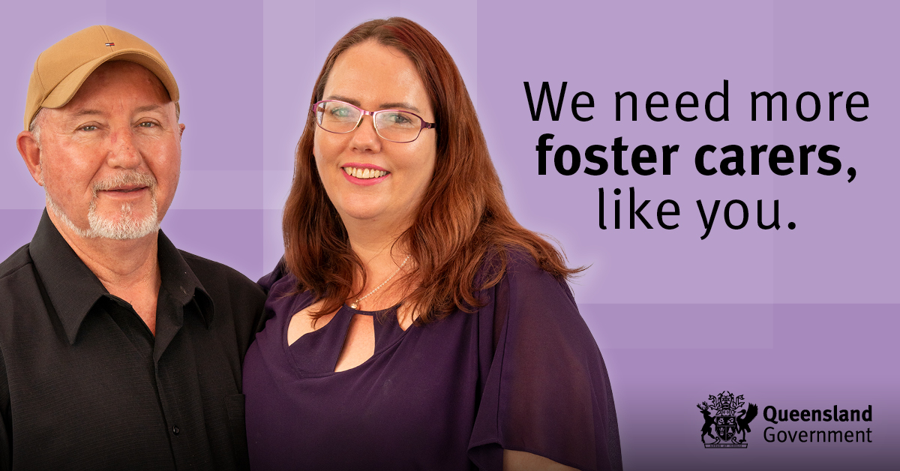  https://youtu.be/5mHXhjiwrV0 | Joy and Anthony  “If you have space in your life for even just one little person, even if it’s for a short period of time, we need carers to invest in the lives of these young people.”  After spending time in the foster care system herself as a teenager, Joy and her husband Anthony have now been fostering for many years and say it’s opened their own children’s eyes to the meaning of community.  To find out more about becoming a foster carer, visit <insert agency website>.  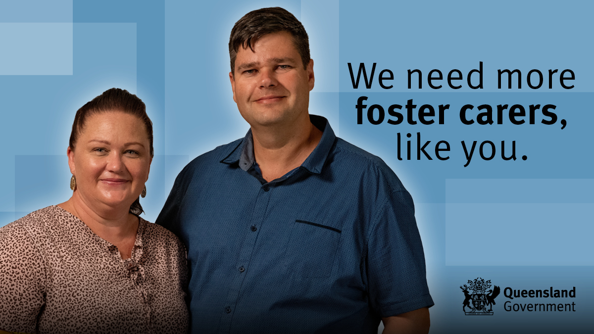  https://youtu.be/qneydKwALRk
Aunty Karmen  After receiving help when she was younger, Aunty Karmen was determined to give back through fostering. Now she proudly ensures the First Nations children she cares for maintain a connection to their culture.  “If you’ve got that room in your heart, and that open mind, and just that willingness to want to help somebody, just do it. They’re going to melt your heart.”  To find out more about becoming a foster carer, visit <insert agency website>.  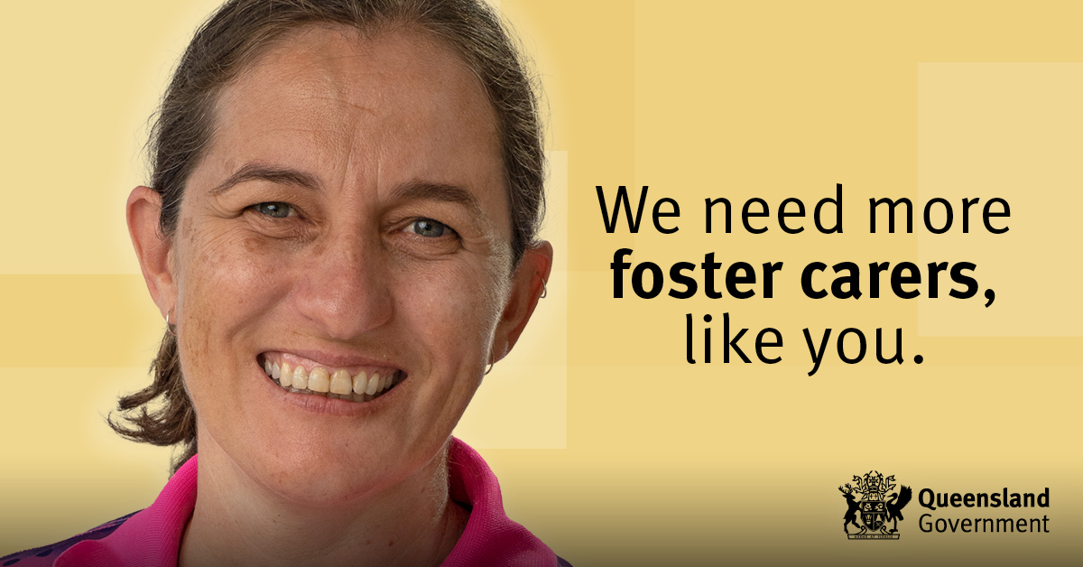https://youtu.be/YtB5BKDIzHI | Karyn and Ron  “The very first question they asked me was, ‘Why do you want to do this, why do you want to become a foster carer?’  “Every child deserves a chance. A chance at education, a roof over their head, clothes on their back, shoes on their feet, food in their belly. Something that I had all my life, so it was a given for me. And stepping into this world – not every child has that.”  Foster carers Karyn and Ron know fostering needs special people with extraordinary hearts. To find out more about becoming a foster carer, visit <insert agency website>.  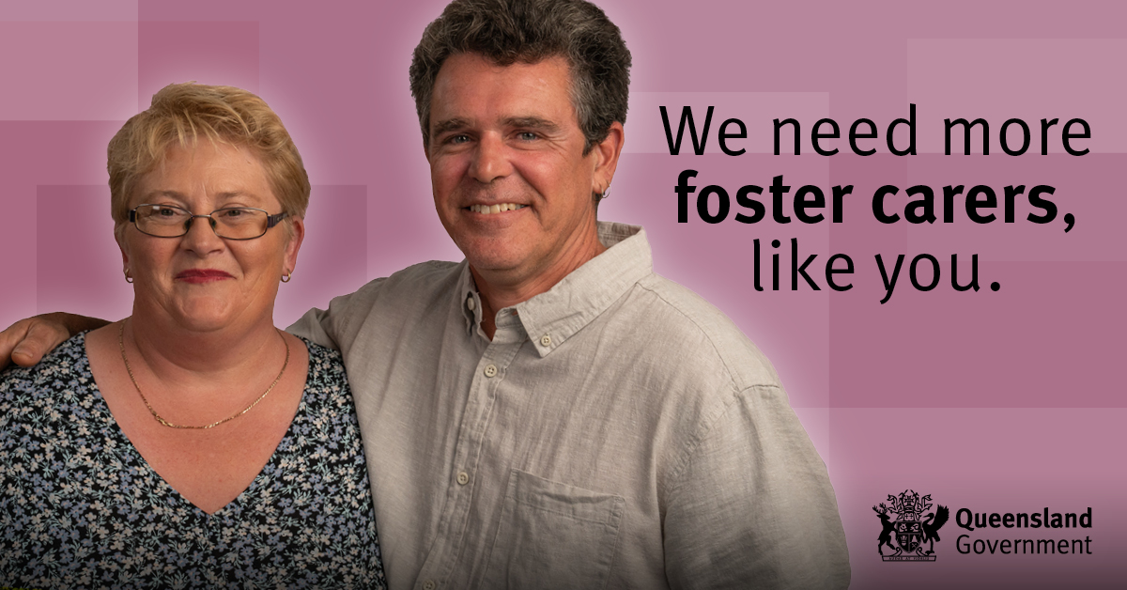  https://youtu.be/oRoXq6q1yC4
Justin  “It’s definitely worth doing. It’s been life changing for me and I wouldn’t change it now.”  As a single, full-time worker, Justin found the idea of being a foster carer daunting in the beginning. But his advice for others is to take the leap.  “It’s worth it for you and it’s worth it for them.”  If you think you could make a difference in a child’s life like Justin, then visit <insert agency website> to find out more about becoming a foster carer.  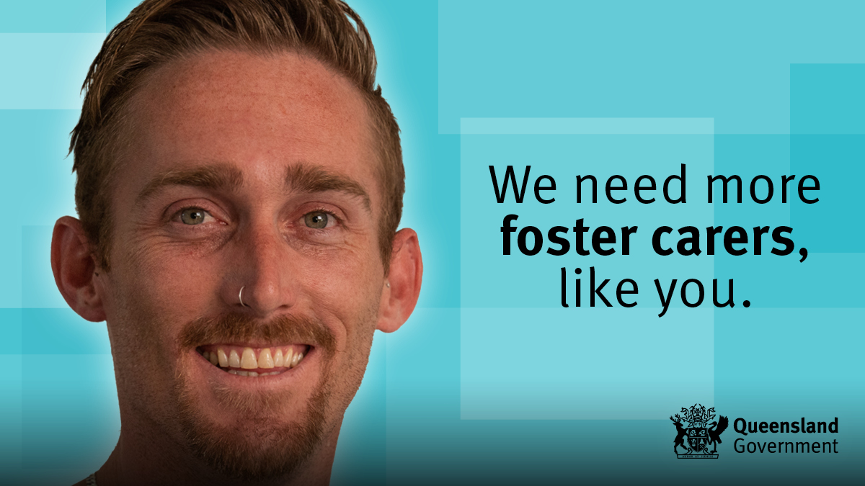https://youtu.be/zvKKBaFiig8 | Melissa and Scott  Melissa and Scott had five kids of their own when they decided to become foster carers.  While a little nervous at first, fostering soon became second nature to the whole family, and after many years Melissa and Scott have seen just how nurturing their own children have been towards the foster children.  The couple feel a sense of pride knowing fostering has helped their children to become better adults and they plan to continue caring for a lot longer yet.  To find out more about becoming a foster carer, visit <insert agency website>.  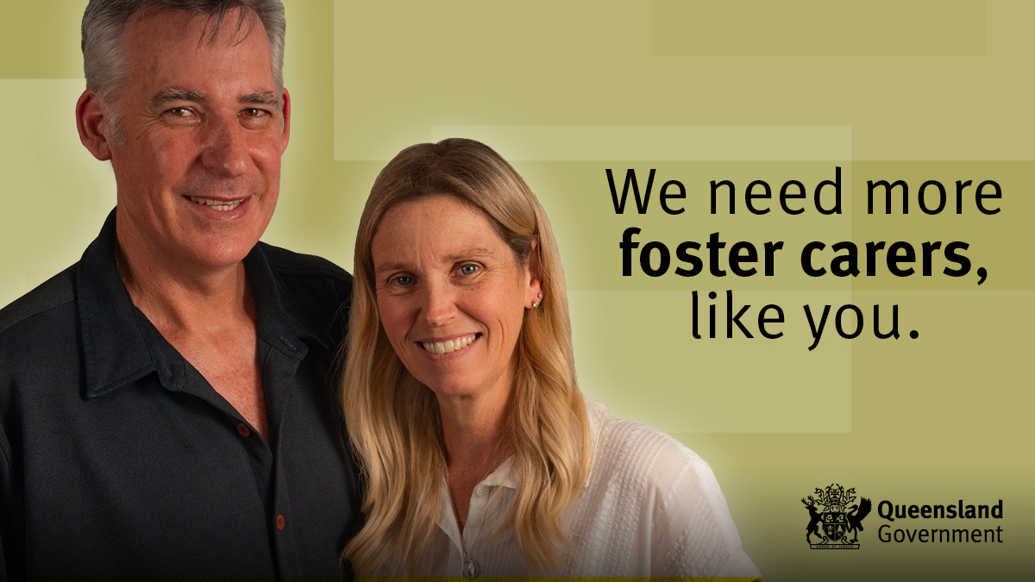  https://youtu.be/OPRD7AJdBEA

Sandra and Rick  Just knowing that there were children in need of a home and stability was the reason Sandra and her husband Rick became foster carers.  Their advice for anyone thinking about fostering is that the reward can outweigh any of the fears you had at the beginning.  “When you look back, you'll think, wow – I could have done a million things with my time, but what I've chosen to do to help these children, well money can't buy that,” says Rick.  To find out more about becoming a foster carer, visit <insert agency website>.  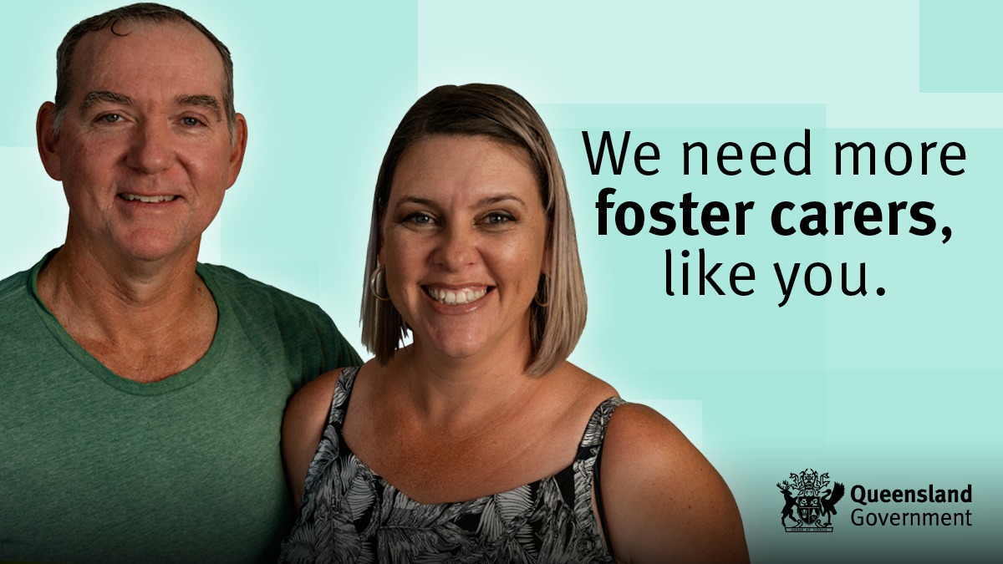https://youtu.be/KMeAyMU-2ec | Uncle Allan and Cheryl  “Kids need you. They need a safe place. They need a bit of love in their life.”  Uncle Allan and Cheryl have been foster carers for decades, after recognising the need in their local area.  They’re passionate about providing care to Aboriginal children to ensure they grow up in culture and they say they’re lucky enough to remain in contact with a lot of the kids they fostered who are now grown. Uncle Allan even walked two of his foster children down the aisle.  It doesn’t matter what age you are, Cheryl says. “It’s a journey and I’m not ready to retire yet.”  To find out more about becoming a foster carer, visit <insert agency website>.  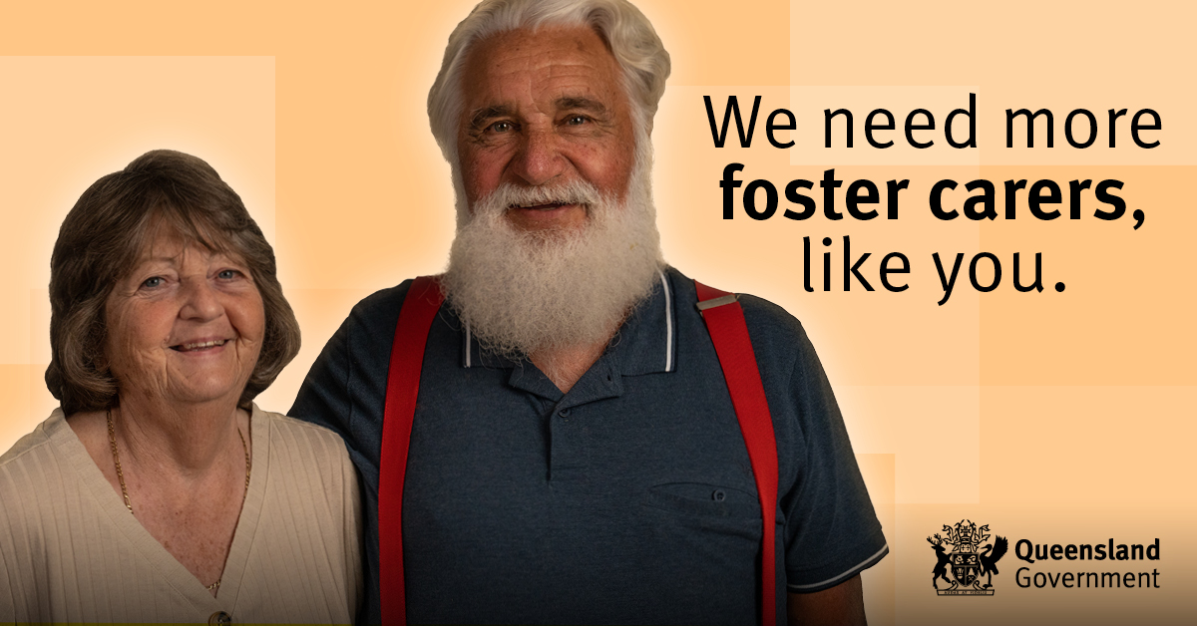https://youtu.be/9SvFSZjryVI

YouTube playlist
This playlist includes all long-form foster carer videos https://youtube.com/playlist?list=PL2_9nQkgOf0u6nyrpaoNux_fO0QodWZ2a

Additional content
Below is some additional content to educate and address some of the common barriers to fostering.
Images are available to download at https://www.dcssds.qld.gov.au/campaign/foster-care-recruitment/resources

Post 1: Top questions – couples
Do you have to be married to be a foster carer?
Can same-sex couples apply?
Can you still be a foster carer if you work full-time?
What if you already have kids?
Read the answers to top questions about foster caring to help you work out if it’s right for you.
https://www.qld.gov.au/community/caring-child/foster-kinship-care/foster-kinship-care-become-a-carer/foster-kinship-care-top-questions

Post 2: Top questions – singles
Can you be a foster carer if you live alone?
What if you work full-time?
Do you need to have a big house?
What training and support is there?
Read the answers to top questions about foster caring to help you work out if it’s right for you.
https://www.qld.gov.au/community/caring-child/foster-kinship-care/foster-kinship-care-become-a-carer/foster-kinship-care-top-questions

Post 3: Short breaks care
Could you foster a child on a weekend?
Short breaks foster care is caring for a child for just a short period of time, like a weekend. It used to be called respite care and provides breaks for long-term foster carers.
Short breaks care suits many families who can’t commit to full-time care. Many new carers also start out providing short breaks and then choose to become full-time foster carers after gaining some experience.
If short breaks care could be right for your family, find out more about becoming a foster carer by visiting www.qld.gov.au/fostercare.

Share our posts
Alternatively, you can share these Facebook posts:
- Short breaks care
- Training and support
- Top questions about foster care

Your agency can easily share these live Facebook posts and write your own introduction that includes your call to action and contact information.

Tips for using social media tiles and videos
- Whether you choose to share an image or share a video, you can use the content provided, or add your own call to action including your agency’s phone number and website.
- While we cannot supply the MP4 files for the videos, you can share the videos directly to your Facebook page from our Facebook playlist.
- You can also embed the YouTube videos or YouTube playlist on your agency’s website.

